**Practice Exam**

**Report : Hà Quang Minh**

**Question 1**

**Lấy laptop dung dây console**

**Question 2 :**

**Question 3 :**

**My solution :**

**Chia address : 192.168.1.0 /24**

Chia ra thành 4 mạng con.

**Configure Subinterfaces**

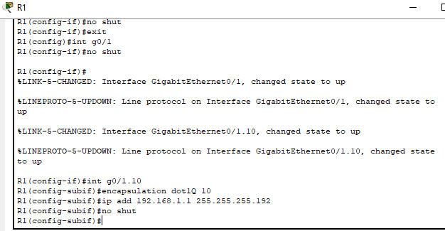

**EIGRP on R1**

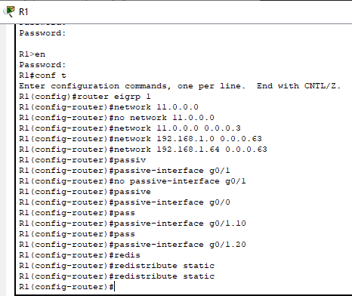

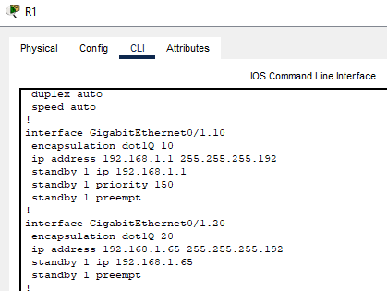

**EIGRP on FullName**

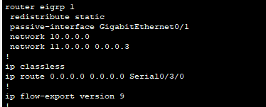

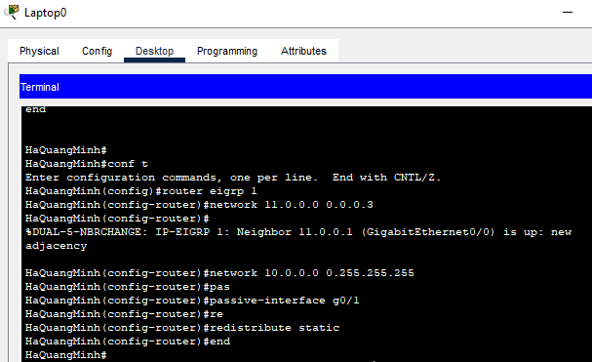

**DHCP**

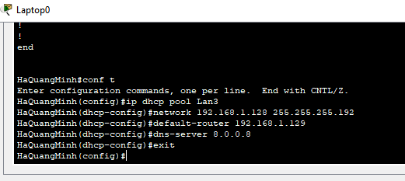

Ghi DHCP xong r ( nhớ cấp địa chỉ ip g0/1 vào PC3-1 để cho nó cấp successfully

**Setup eiu.edu.vn**

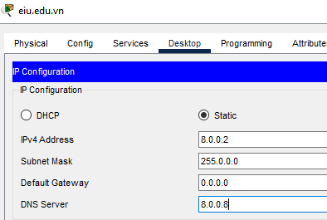

**Setup DNS**

